Clean streets for clean rivers


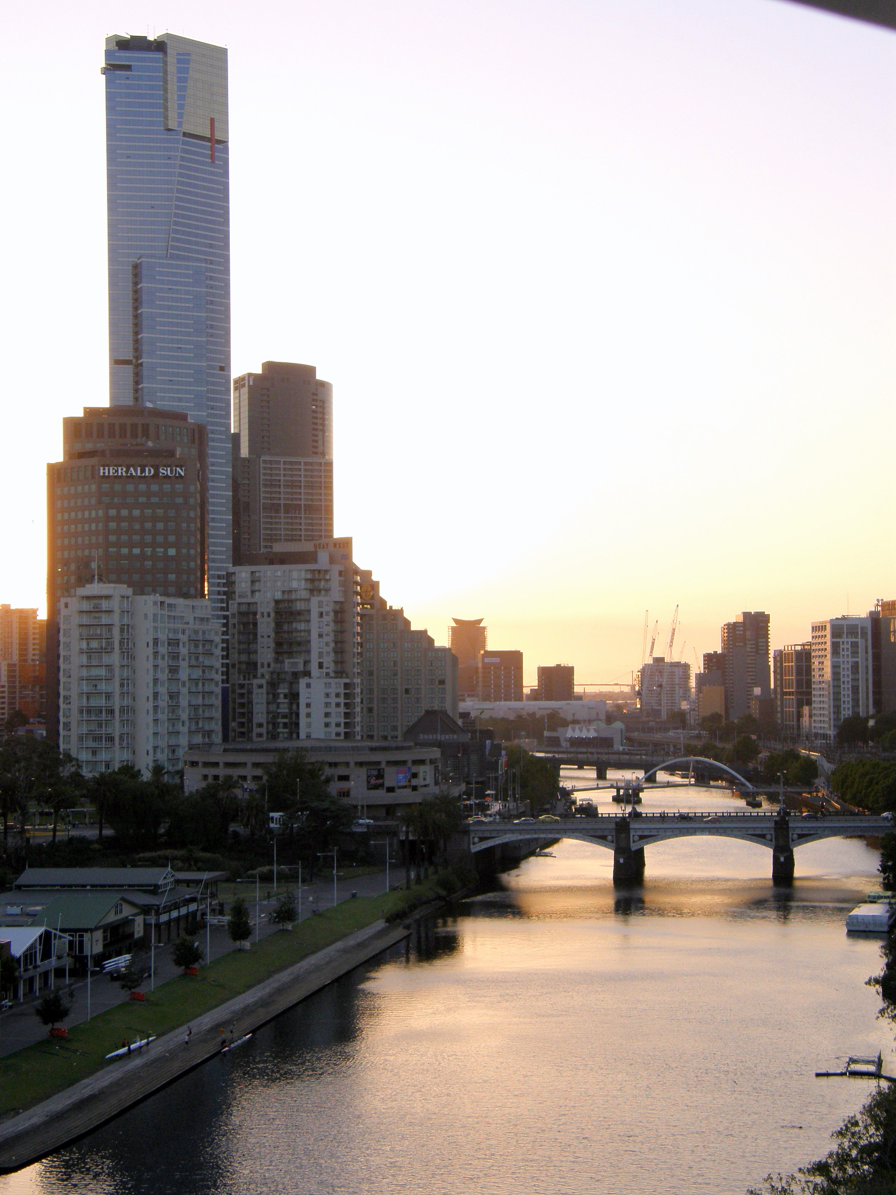
- Pre-reading discussion 
- Look at the picture. What do you see?
  - Name four things you can see in this picture.
  - Have you seen this place?
  - What is the name of this city and this river?
  - Where does this river pour out to?
- Rivers you know.
  - What is the name of a river in the country you come from?
  - Did you live near a river?
  - What can you tell us about a river you know? Do you have any special memories?

- Look at the diagram below.
  - How many different things can you see? Write the words on the picture.
  - What are the different types of rubbish you can see?
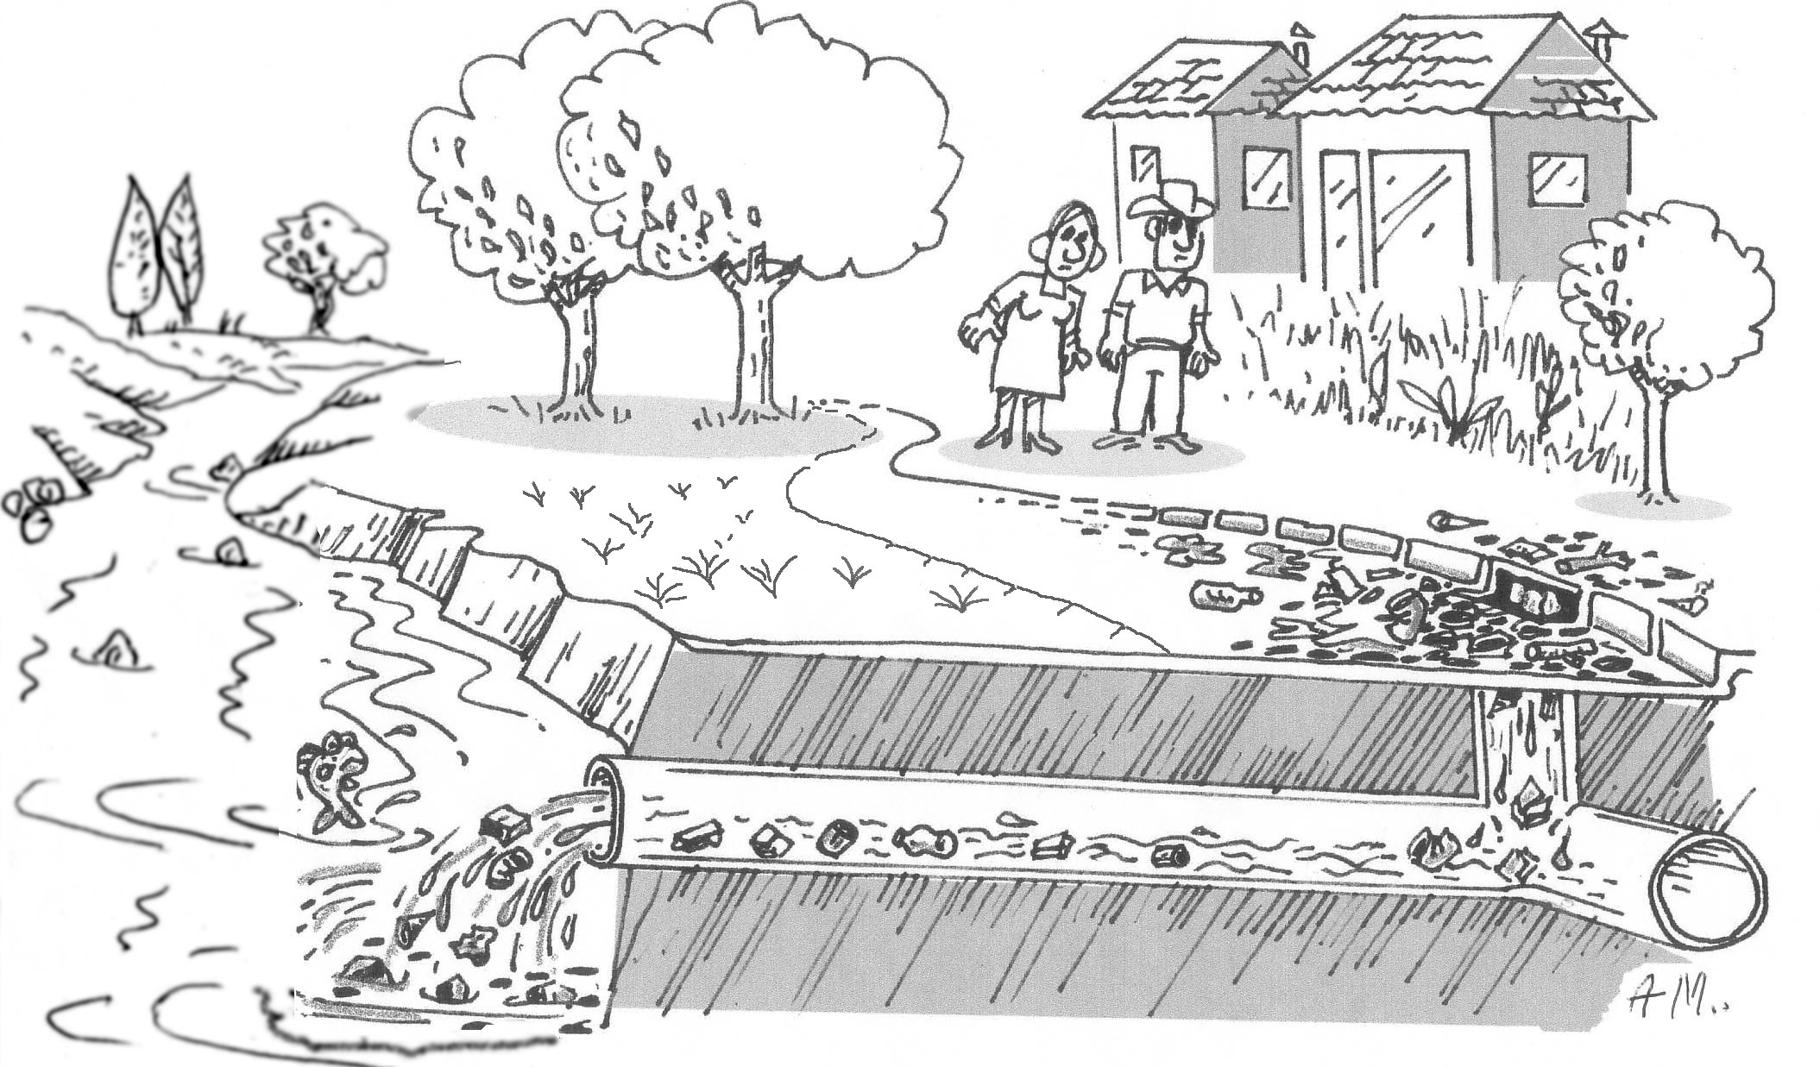
  - What is happening?

- Vocabulary
a. Write the following three words under the matching picture. | pipe | creek | drain
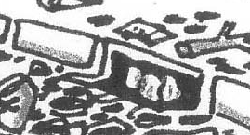
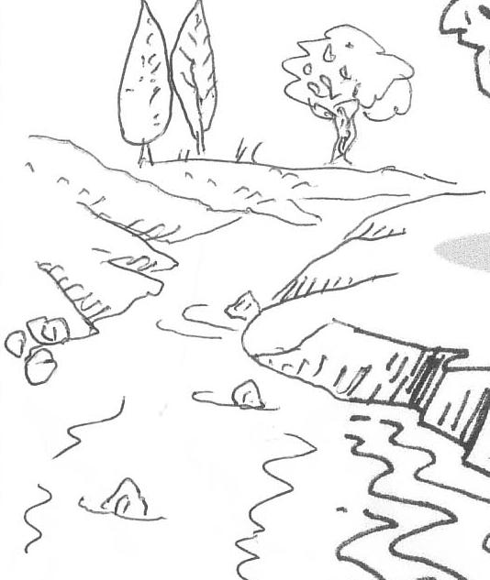

b. Match the word on the left with the meaning on the right.
flow | musical sound made by birds
bought | arrive, finish
favourite | runs smoothly and gracefully
forecast | like this the best
twittering | buy (past tense)
end up | say what will happen

How the street changed the creek

Salina and Joe love fishing. When they got married they bought a house near a small river. They enjoyed their days fishing. They watched the water flow by and listened to the birds twittering in the morning.
When they had children, the whole family went to the creek and had a wonderful time together. The children got older, life got busy and they had less time to go fishing. Their children grew up and started living their own life. Joe retired and once again Joe and Salina had more time to together.
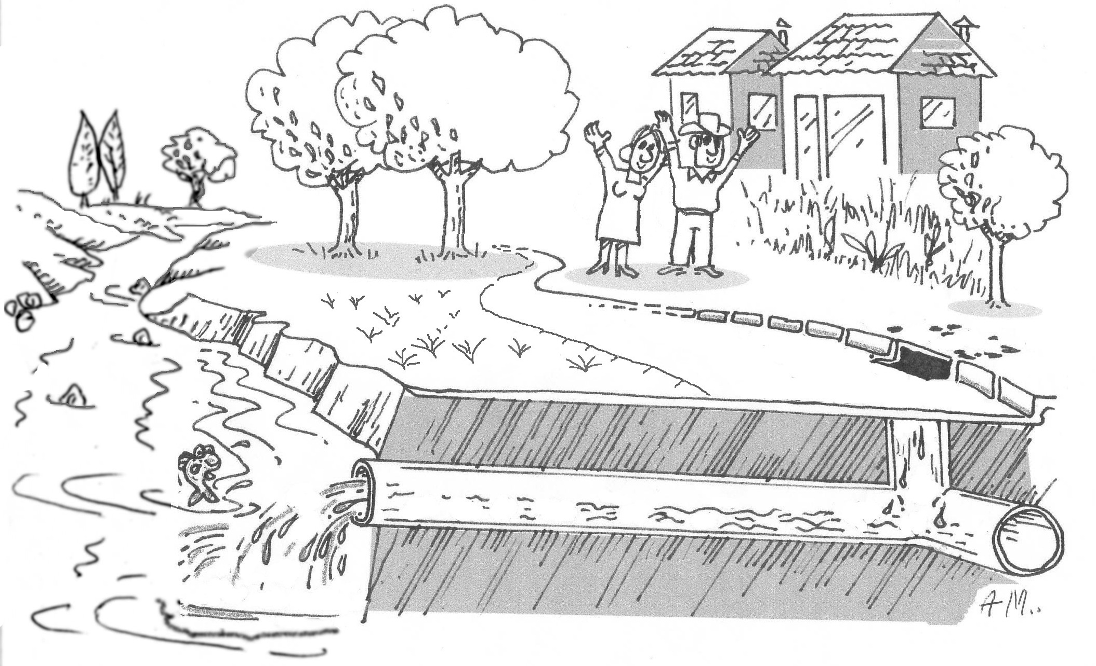
One morning, Joe felt like going fishing. “How about we walk down to the creek for some fishing?” Joe asked Salina.
“It was raining last night” replied Salina, “It might keep raining today.”
Joe looked at the weather forecast in the newspaper and looked outside. “We have good news,” said Joe, “we will have lovely weather today”.
They packed their fishing things, a frying pan for cooking the fish and some drinks.
As they walked along the road, they saw many new roads and new buildings. When they got down to their favourite place on the creek, they had an awful shock. There was so much rubbish on the roads.
The rain had washed all the rubbish down to the drain. The rubbish, together with the water was going down the pipes and into the creek!
Salina and Joe went back home and wrote a letter to their newspaper. In the letter, they explained that if we all keep the streets clean, we help keep the creeks and rivers clean. If there is rubbish on the street, it will flow down the drain, into the pipes and then into the river. Then, all the water and rubbish in the river will flow out to the beaches.
Many people read Joe and Salina’s letter. They all made sure rubbish would not blow in the wind and they did not drop their cigarette butts on the ground.

Next time Joe and Salina went down to the creek, they had a wonderful surprise! Only the rain water was going down the drain. The street was lovely and clean and the creek was clean. They were happy and the fish were happy!

- Story summary and language
Past tense. Verbs can have a present tense form or they can have a past tense form. The different forms of verbs can be regular; where we add –ed, or irregular.
Here are some past tense and present tense forms of regular and irregular verbs.
Regular verbs |  | Irregular verbs
Present | Past | Present | Past
love | loved | have | had
live | lived | feel | felt
retire | retired | see | saw
ask | asked | get | got
wash | washed | write | wrote
want | wanted | go | went
notice | noticed | read | read
stop | stopped | is | was
Complete the story summary. Use the past tense verbs from the box.
Joe and Salina __________ fishing and they __________ near a creek. Joe __________ and they ______ more time to together. One morning, Joe __________ like going fishing. He __________ Salina if she __________ to go fishing. They __________ that it stopped raining, so Salina agreed to go with Joe.
When they _______ to the creek, they __________ a lot of rubbish on the street. The rain had __________ all the rubbish from the street, down the drain and then into the creek. From the creek, all the rubbish __________ into the big river and then out to the beaches.
Joe and Salina __________ a letter to their newspaper. Many people _________ Joe and Salina’s letter. Next time Joe and Salina ________ down to the creek, they had a wonderful surprise! The street __________ lovely and clean and the creek was clean.

- Deeper Understanding
Number these sentences in the correct order.
The rubbish ends up on the beach.
Someone forgets their rubbish on the bus stop seat.
The next day it rains and everything gets washed into the drain.
The wind blows the rubbish from the seat onto the street.
The rubbish and water run through the drain and empty into the creek.
- Getting ready for the quiz…
Which rivers and creeks are near you? Answer these questions and discover interesting information about the area around Melbourne.

a) Rivers that flow into Port Phillip Bay
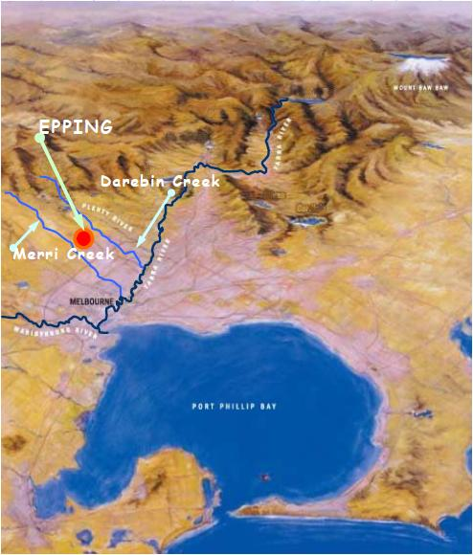
Insert the correct word to complete each of the following sentences.
into longer into between
- Epping is _____________________ Darebin Creek and Merri Creek.
- Merri Creek flows _____________________ the Yarra River.
- The Yarra River flows _________________ Port Phillip Bay.
- The Yarra River is _____________________ than Merri Creek.
                - Pronunciation of numbers
Number | How many syllables in that number? | 1. Write the number in full here, using a black or blue pen.  2. Re-write over the stress syllable using a red pen.  (The first one has been done for you)
18 | 2 | eighteen
17
70
90
19
50

- Have a guess: Litter quiz!

Circle the option you think is the right answer
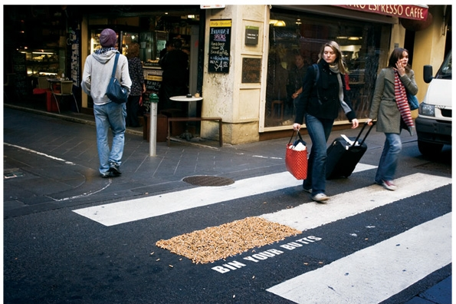
- In this photo, what are the light brown
things on the end of the white line?
a) paint
b) leaves
c) cigarette butts
d) shopping dockets.

Litter quiz continued
- How much of the rubbish in the rivers and beaches comes from the streets?
a) 10%
b) 95%
c) 50%
d) 99%

- How much money does the government spend on cleaning up rubbish from streets (in Victoria) every year?
a) $41 million
b) $18 million
c) $ 2 million
d) $1.5 million
- In the whole world, how many cigarette butts are thrown on the street each year?
a) 18 million
b) 100 million
c) 4.5 million million
d) 1 billion
- Each year, how many cigarette butts are washed into the creeks and beaches of Victoria?
a) 18 million
b) 100 million
c) 1000 million
d) 6 billion
- How much is the fine if people drop a lit cigarette butt on the street?
a) $29
b) $55
c) $227
d) $1000
- Finding solutions
What are your ideas about solving the problem for different types of litter? Discuss this with your group and write down as many different ideas you can think of.
  - Cigarette butts

  - Plastic bags
  - Drink containers.
- Main idea
Complete this sentence. It is about the main idea of the story.
For beaches and rivers to be clean, . . . . .

My feedback about this lesson

 | Tick in the boxes that you agree with.
 | This helped me learn English | This did not help me learn English | I found this interesting. | I did not find this interesting.
Pre-reading discussion
Vocabulary
Reading the story
Comprehension and writing
Pronunciation
The Quiz
The part of this lesson I did not like:
The part of this lesson I liked best:

